4G

🚀 What Is 4G (Fourth Generation Mobile Network)?
# Source: Chatgpt (GPT-5-Mini) at [1/23/2026]
4G, or Fourth Generation mobile network, is a high-speed, all-IP-based wireless system that enables fast internet access, HD video streaming, online gaming, video calls, and mobile apps on smartphones and other devices.
📲 4G turned mobile phones into full-powered internet devices, offering speeds like home broadband — anytime, anywhere.

🌐 Key Features of 4G:
# Source: Chatgpt (GPT-5-Mini) at [1/23/2026]
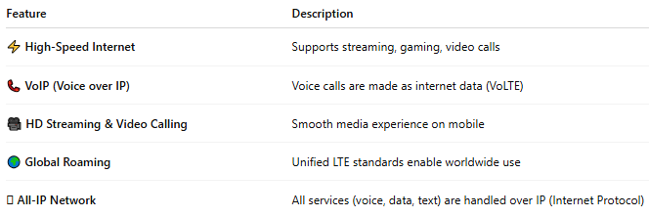

Feature | Description
⚡ High-Speed Internet | Supports streaming, gaming, video calls
📞 VoIP (Voice over IP) | Voice calls are made as internet data (VoLTE)
🎥 HD Streaming & Video Calling | Smooth media experience on mobile
🌍 Global Roaming | Unified LTE standards enable worldwide use
🛜 All-IP Network | All services (voice, data, text) are handled over IP (Internet Protocol)

📶 4G Speed Ranges:
# Source: Chatgpt (GPT-5-Mini) at [1/23/2026]
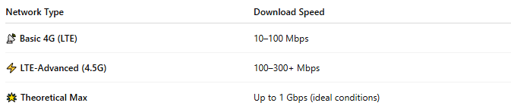

Network Type | Download Speed
📡 Basic 4G (LTE) | 10–100 Mbps
⚡ LTE-Advanced (4.5G) | 100–300+ Mbps
🌟 Theoretical Max | Up to 1 Gbps (ideal conditions)

🧱 Core 4G Technologies:
# Source: Chatgpt (GPT-5-Mini) at [1/23/2026]
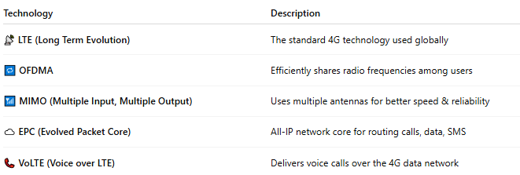

Technology | Description
📡 LTE (Long Term Evolution) | The standard 4G technology used globally
🔁 OFDMA | Efficiently shares radio frequencies among users
📶 MIMO (Multiple Input, Multiple Output) | Uses multiple antennas for better speed & reliability
☁️ EPC (Evolved Packet Core) | All-IP network core for routing calls, data, SMS
📞 VoLTE (Voice over LTE) | Delivers voice calls over the 4G data network

📲 What 4G Made Possible:
# Source: Chatgpt (GPT-5-Mini) at [1/23/2026]
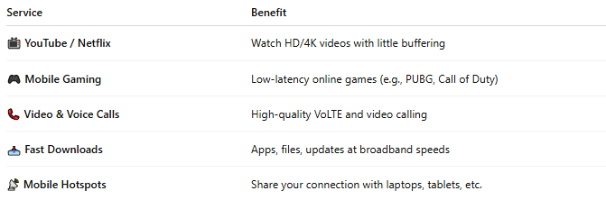

Service | Benefit
📺 YouTube / Netflix | Watch HD/4K videos with little buffering
🎮 Mobile Gaming | Low-latency online games (e.g., PUBG, Call of Duty)
📞 Video & Voice Calls | High-quality VoLTE and video calling
📥 Fast Downloads | Apps, files, updates at broadband speeds
📡 Mobile Hotspots | Share your connection with laptops, tablets, etc.

📉 Limitations of 4G:
# Source: Chatgpt (GPT-5-Mini) at [1/23/2026]
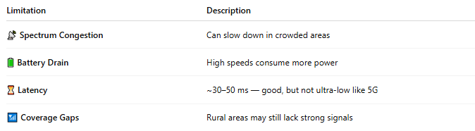

Limitation | Description
📡 Spectrum Congestion | Can slow down in crowded areas
🔋 Battery Drain | High speeds consume more power
⏳ Latency | ~30–50 ms — good, but not ultra-low like 5G
📶 Coverage Gaps | Rural areas may still lack strong signals

🕰️ 4G Timeline:
# Source: Chatgpt (GPT-5-Mini) at [1/23/2026]
- 📆 First launch: 2009 (Sweden & Norway)
- 🌍 Global rollout: 2010–2015
- 🔄 Still active: Serves as fallback for 5G devices

📖 Summary:
# Source: Chatgpt (GPT-5-Mini) at [1/23/2026]
4G brought the mobile internet to life:
- ✅ Fast: Up to 100x faster than 3G
- ✅ Reliable: Seamless video, apps, and web access
- ✅ All-IP: Unified voice, data, and text over one network
It transformed phones into full-featured mobile computers, paving the way for smart cities, IoT, and 5G.

